**Project Development phase**

**Project Development delivery of sprint 3**

|  |  |
| --- | --- |
| Team ID | PNT2022TMID50833 |
| Project name | Plasma donorapplication |

**Flow chart:**

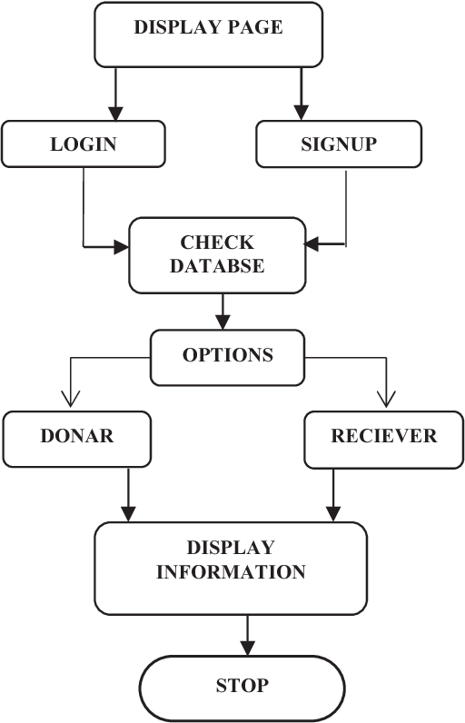

**Concept:**

* To build a platform between plasma donors and receivers.
* To implement a hybrid approach of K-means and Agglomerative clustering.
* To find the nearest donor in specific region in the shortest possible time.
* To increase the number of voluntary unpaid blood donations significantly.

Advantages

* It isuser- friendly applications.
* It will help people to find plasma easily.

Disadvantages

* + - It cannot auto verify user genuineness.
    - It requires an active internet connection.